BM8-B TABLE OF COLORED PART 2013

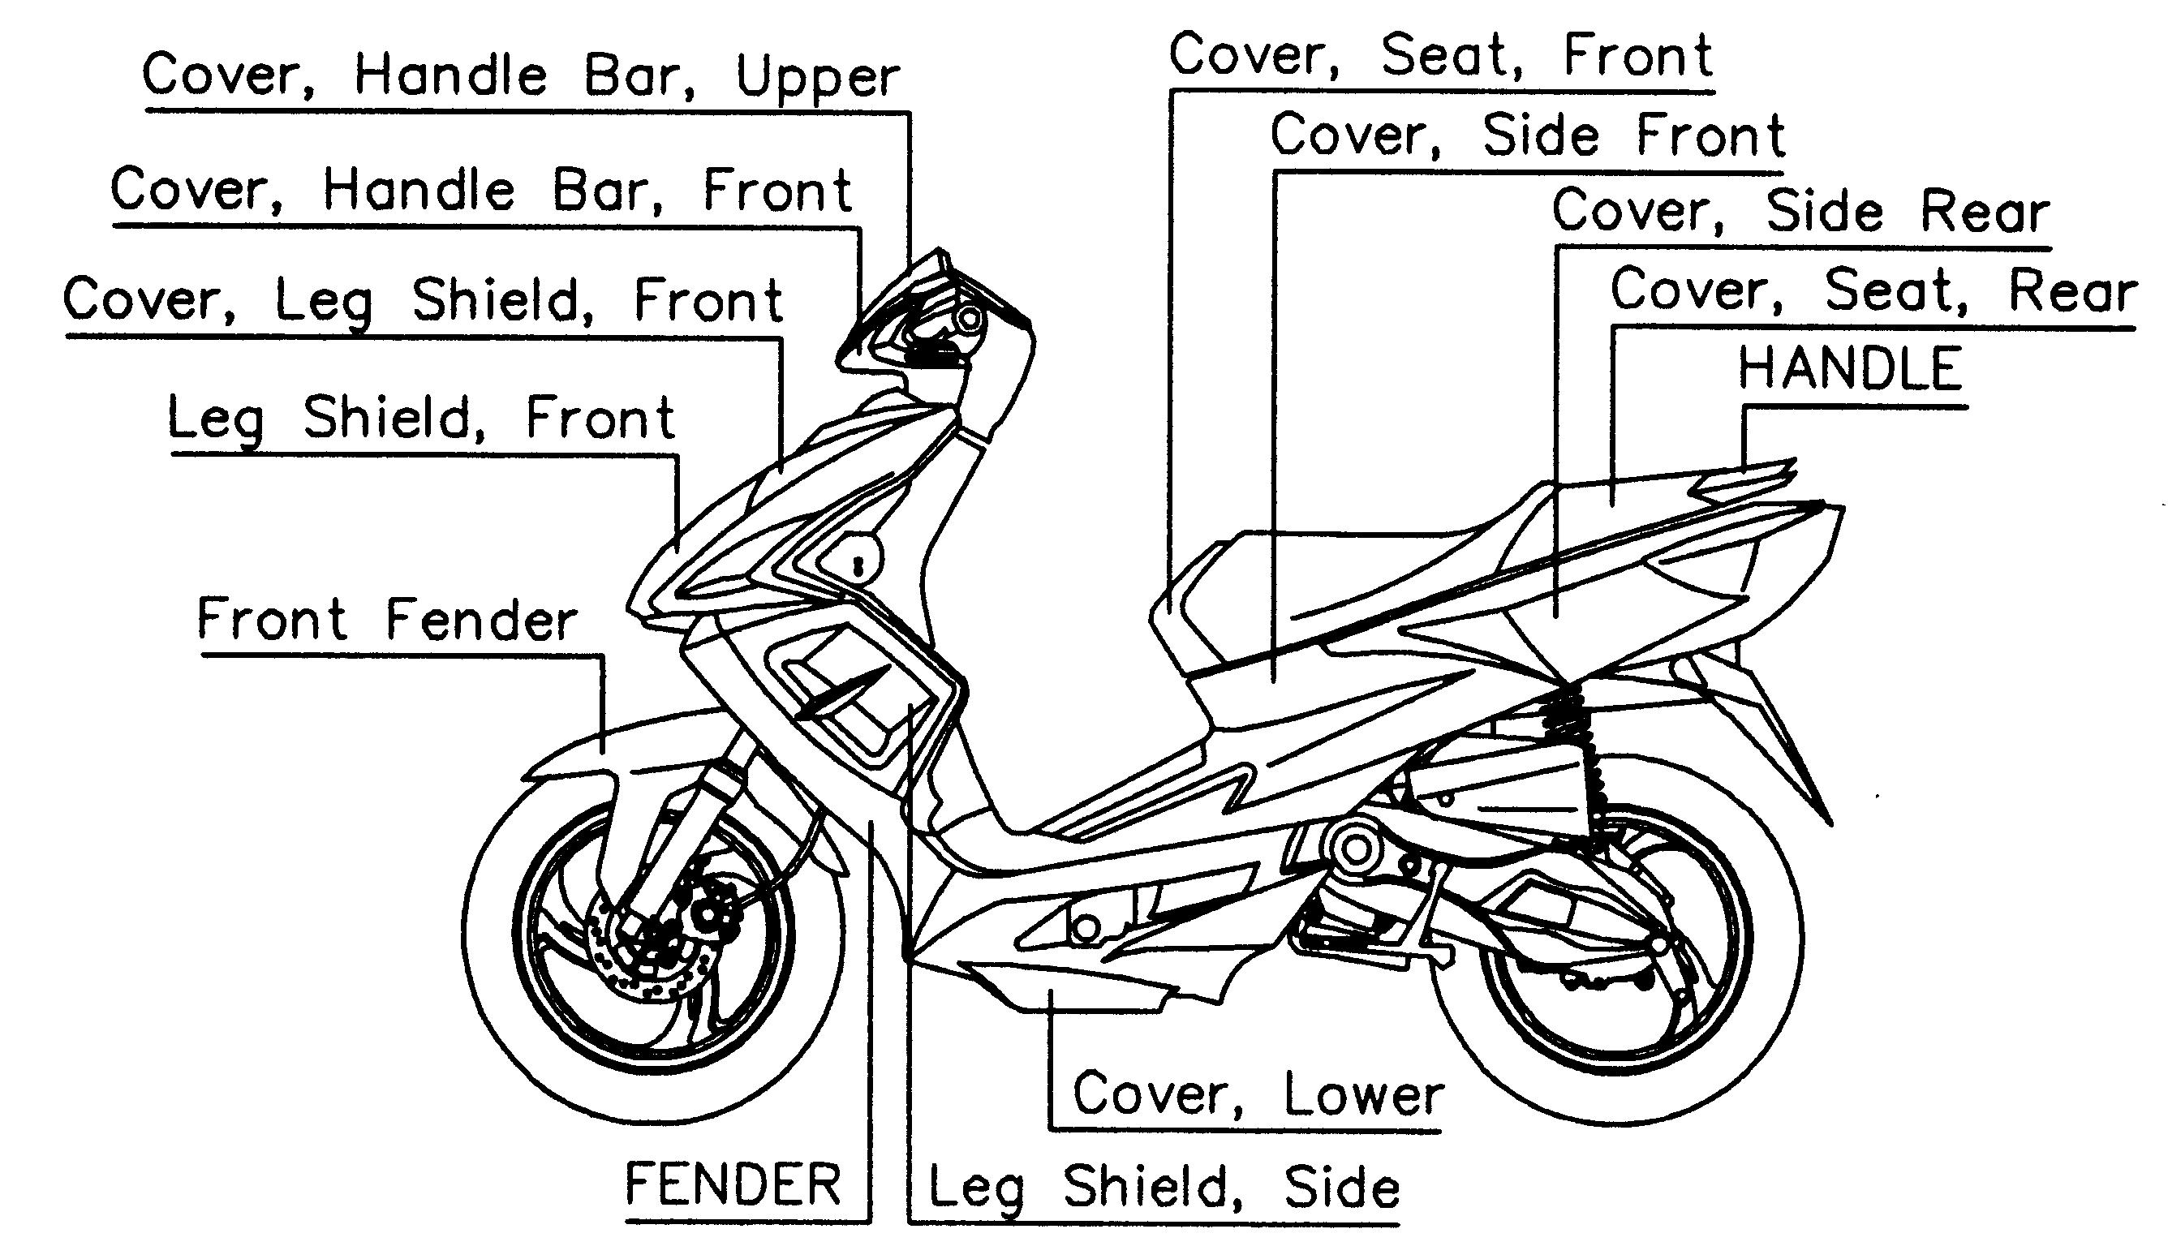

TABLE OF COLORED PART (BULL&T RS)
ITEM  NO. | CODE | A | B
ITEM  NO. | Basic Color  Description | Pearly Luster Black  /  Bright White | Pearly Luster Black  /  Lemon Yellow
ITEM  NO. | Basic Color  Description | PK / BW  BLA612 / WHI 707 | PK / LY  BLA612 / YEL 705
 | Cover, Seat, Front, With Emblem | 452051MCF1 | 452051MCF2
23 | Cover, Seat, Front | 452051MC | 452051MC
 | Emblem | 459987PS | 459987PS
 | Emblem | 415014AR | 415014PS
 | Cover, Side Front, LH., With Emblem | 453051SELJ | 453051SELK
 | Cover, Side Front, LH. | 453051SE | 453051SE
 | Emblem | 415015AR | 415015PS
 | Cover, Side Front, RH., With Emblem | 453052SERJ | 453052SERK
 | Cover, Side Front, RH. | 453052SE | 453052SE
 | Emblem | 415016AR | 415016PS
24 | Cover, Side Rear, LH., With Emblem | 453053PK/BWLA4 | 453053LY/BWLA5
 | Cover, Side Rear, LH. | 453053PK/BW | 453053LY/BW
 | Emblem | 415012AR | 415012PK
 | Cover, Side Rear, RH., With Emblem | 453054PK/BWRA4 | 453054LY/BWRA5
 | Cover, Side Rear, RH. | 453054PK/BW | 453054LY/BW
 | Emblem | 415013AR | 415013PK
 | HANDLE., With Emblem | 453056BWR2 | 453056BWR2
 | HANDLE | 453056BW | 453056BW
 | Emblem | 415014PK | 415014PK
 | COVER, LEG SHIELD, FRONT | 454039SE | 454039SE
 | ORNAMENTAL COVER | 454040SE | 454040SE
 | Leg Shield, Front., With Emblem | 454038PKF8 | 454038LYF9
25 | Leg Shield, Front | 454038PK | 454038LY
 | Emblem | 415000AR | 415000PK
 | Emblem | 415001AR | 415001PK
 | Emblem | 415002AR | 415002PS
 | Emblem | 415003AR | 415003PS
 | FENDER, INNER., With Emblem | 455030BWDG | 455030PKDH
26 | FENDER, INNER | 455030BW | 455030PK
 | Emblem | 415008AR | 415008PS
 | Emblem | 415009AR | 415009PS

I
BM8-B TABLE OF COLORED PART 2013

TABLE OF COLORED PART (BULL&T RS)
ITEM  NO. | CODE | A | B
ITEM  NO. | Basic Color  Description | Pearly Luster Black  /  Bright White | Pearly Luster Black  /  Lemon Yellow
ITEM  NO. | Basic Color  Description | PK / BW  BLA612 / WHI 707 | PK / LY  BLA612 / YEL 705
 | Leg shield, Side, LH., With Emblem | 455031BWLC | 455031PKLD
 | Leg shield, Side, LH. | 455031BW | 455031PK
 | Emblem | 415022AR | 415022PS
 | Leg shield, Side, RH., With Emblem | 455032BWRC | 455032PKRD
 | Leg shield, Side, RH. | 455032BW | 455032PK
26 | Emblem | 415023AR | 415023PS
 | Cover, Lower, LH., With Emblem | 455046PKLR | 455046LYLS
 | Cover, Lower, LH. | 455046PK | 455046LY
 | Emblem | 415010AR | 415010PK
 | Cover, Lower, RH. , With Emblem | 455047PKRR | 455047LYRS
 | Cover, Lower, RH. | 455047PK | 455047LY
 | Emblem | 415011AR | 415011PK
 | Front Fork, With Emblem | 412704SEG | 412704SEG
27 | Front Fork | 412704SE | 412704SE
 | Emblem | 415021 | 415021
28 | Front Fender | 456010MC | 456010MC
 | Rim Comp., Front, With Emblem | 412927YYGFF | 412927YYGFG
29 | Rim Comp., Front | 412927YYG | 412927YYG
 | Emblem | 415019AR | 415019LY
 | Emblem | 415020AR | 415020LY
 | Cover, Handle Bar, Upper, With Emblem | 457165SEF1 | 457165SEF1
 | Cover, Handle Bar, Upper | 457165SE | 457165SE
 | Emblem | 459934 | 459934
31 | Cover, Handle Bar, Front, With Emblem | 457127PKF4 | 457127LYF5
 | Cover, Handle Bar, Front | 457127PK | 457127LY
 | Emblem | 415017AR | 415017PK
 | Emblem | 415018AR | 415018PK
 | Rim Comp., Rear, With Emblem | 413400YYGRE | 413401YYGRF
34 | Rim Comp., Rear | 413401YYG | 413401YYG
 | Emblem | 415019AR | 415019LY
 | Emblem | 415020AR | 415020LY

II
BM8-B TABLE OF COLORED PART 2010

TABLE OF COLORED PART (BULLET RS)
ITEM  NO. | CODE | A | B | C | D
ITEM  NO. | Basic Color  Description | Fresh Red | Classic Blue | Classic Black | Shell White
ITEM  NO. | Basic Color  Description | FE  Red 704 | CB Blu 705 | CL Bla 701 | SH Whi 702
 | Cover, Seat, Front, With Emblem | 452051CF1 | 452051CF1 | 452051CF1 | 452051CF1
23 | Cover, Seat, Front | 452051C | 452051C | 452051C | 452051C
 | Emblem | 459720 | 459720 | 459720 | 459720
 | Cover, Side Front, LH. | 453051SE | 453051SE | 453051SE | 453051SE
 | Cover, Side Front, RH. | 453052SE | 453052SE | 453052SE | 453052SE
 | Cover, Side Rear, LH., With Emblem | 453053FE/SHLQ | 453053CB/SHLR | 453053CL/SHLS | 453053SE/SHLT
 | Cover, Side Rear, LH. | 453053FE/SH | 453053CB/SH | 453053CL/SH | 453053SE/SH
24 | Emblem | 459854SS | 459854SRB | 459854PYA | 459854CG
 | Cover, Side Rear, RH., With Emblem | 453054FE/SHRQ | 453054CB/SHRR | 453054CL/SHRS | 453054SE/SHRT
 | Cover, Side Rear, RH. | 453054FE/SH | 453054CB/SH | 453054CL/SH | 453054SE/SH
 | Emblem | 459855SS | 459855SRB | 459855PYA | 459855CG
 | HANDLE | 453056SS | 453056SR | 453056PY | 453056CG
 | COVER, LEG SHIELD, FRONT | 454039C | 454039C | 454039C | 454039C
 | ORNAMENTAL COVER | 454040C | 454040C | 454040C | 454040C
 | Leg Shield, Front., With Emblem | 454038FEFJ | 454038CBFL | 454038CLFM | 454038SHFN
25 | Leg Shield, Front | 454038FE | 454038CB | 454038CL | 454038SH
 | Emblem | 459798SH | 459798SH | 459798SH | 459798SE
 | Emblem | 459858SS | 459858SRB | 459858PYA | 459858CG
 | Emblem | 459859SS | 459859SRB | 459859PYA | 459859CG
 | FENDER, INNER., With Emblem | 455030SED4 | 455030SED5 | 455030SED6 | 455030SED7
 | FENDER, INNER | 455030SE | 455030SE | 455030SE | 455030SE
 | Emblem | 459852FE | 459852CBB | 459852CLA | 459852SH
 | Emblem | 459853FE | 459853CBB | 459853CLA | 459853SH
 | Leg shield, Side, LH., With Emblem | 455031SEL2 | 455031SEL3 | 455031SEL4 | 455031SEL5
 | Leg shield, Side, LH. | 455031SE | 455031SE | 455031SE | 455031SE
 | Emblem | 459848FE | 459848CBB | 459848CLA | 459848SH
26 | Emblem | 459849SS | 459849SRB | 459849PYA | 459849CG
 | Leg shield, Side, RH., With Emblem | 455032SER2 | 455032SER3 | 455032SER4 | 455032SER5
 | Leg shield, Side, RH. | 455032SE | 455032SE | 455032SE | 455032SE
 | Emblem | 459850FE | 459850CBB | 459850CLA | 459850SH
 | Emblem | 459851SS | 459851SRB | 459851PYA | 459851CG
 | Cover, Lower, LH. | 455046SE | 455046SE | 455046SE | 455046SE
 | Cover, Lower, RH. | 455047SE | 455047SE | 455047SE | 455047SE
 | Front Fork, With Emblem | 412704SEF | 412704SEF | 412704SEF | 412704SEF
27 | Front Fork | 412704SE | 412704SE | 412704SE | 412704SE
 | Emblem | 459857 | 459857 | 459857 | 459857
28 | Front Fender | 456010C | 456010C | 456010C | 456010C
 | Rim Comp., Front, With Emblem | 412927YSEF2 | 412927YSEF1 | 412927YSEF3 | 412927YSEF4
29 | Rim Comp., Front | 412927YSE | 412927YSE | 412927YSE | 412927YSE
 | Emblem | 459862 | 459862 | 459862 | 459862
 | Emblem | 459856SS | 459856SRB | 459856PYA | 459856CG

Ⅰ
BM8-B TABLE OF COLORED PART 2010

TABLE OF COLORED PART (BULLET RS)
ITEM  NO. | CODE | A | B | C | D
ITEM  NO. | Basic Color  Description | Fresh Red | Classic Blue | Classic Black | Shell White
ITEM  NO. | Basic Color  Description | FE  Red 704 | CB Blu 705 | CL Bla 701 | SH Whi 702
31 | Cover, Handle Bar, Upper | 457165C | 457165C | 457165C | 457165C
 | Cover, Handle Bar, Front | 457127FE | 457127CB | 457127CL | 457127SH
 | Rim Comp., Rear, With Emblem | 413401YSER2 | 413401YSER1 | 413401YSER3 | 413401YSER4
34 | Rim Comp., Rear | 413401YSE | 413401YSE | 413401YSE | 413401YSE
 | Emblem | 459862 | 459862 | 459862 | 459862
 | Emblem | 459856SS | 459856SRB | 459856PYA | 459856CG

II
BM8-B TABLE OF LABEL 2013
Label | Drawing | Description
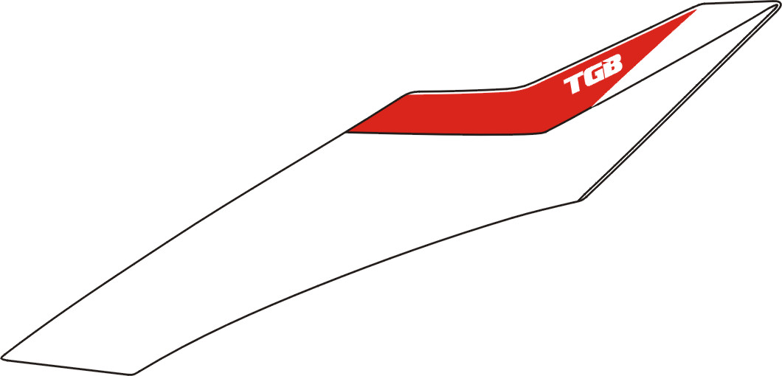 | 415000AR  415000PK | Emblem, Leg Shield, Front, LH.
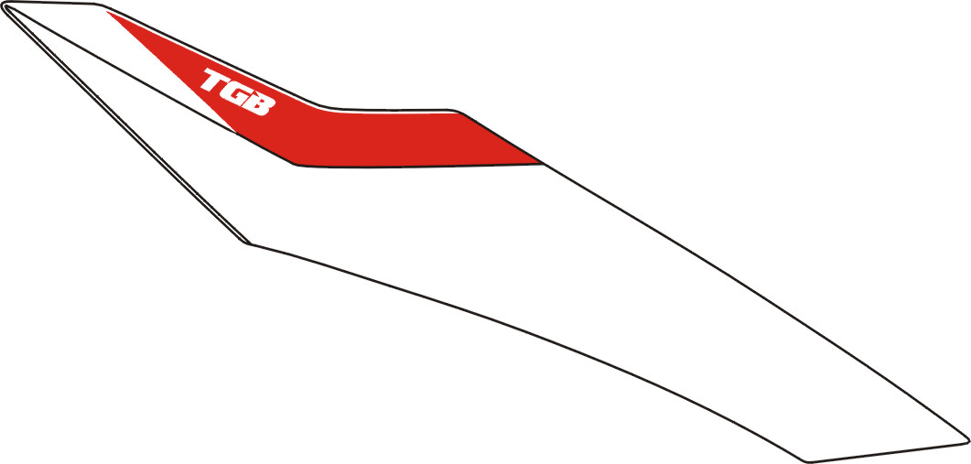 | 415001AR  415001PK | Emblem, Leg Shield, Front, RH.
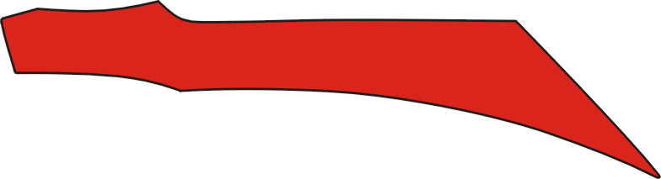 | 415002AR  415002PS | Emblem, Leg Shield, Front, LH.
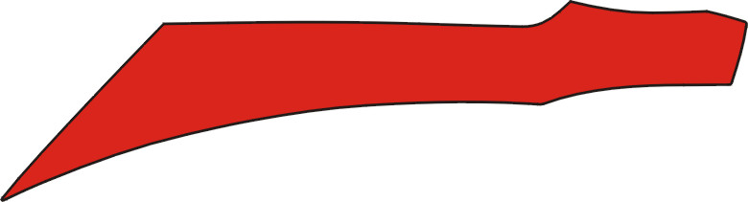 | 415003AR  415003PS | Emblem, Leg Shield, Front, RH.
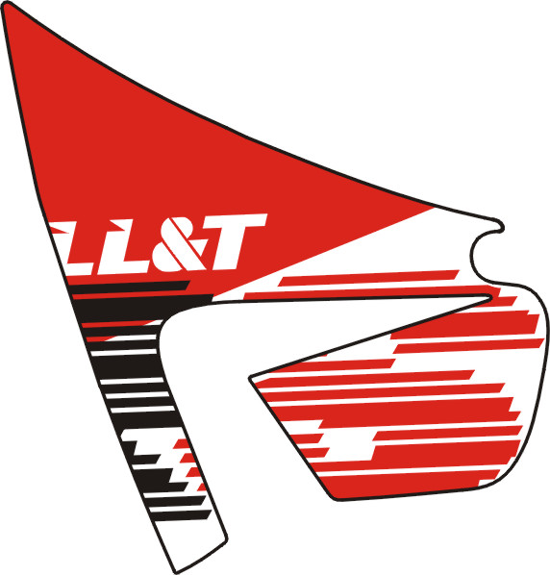 | 415022AR  415022PS | Emblem, Leg shield, Side, LH.
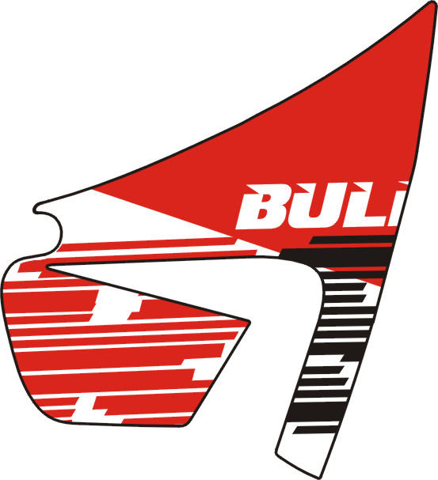 | 415023AR  415023PS | Emblem, Leg shield, Side, RH.

I
BM8-B TABLE OF LABEL 2013
Label | Drawing | Description
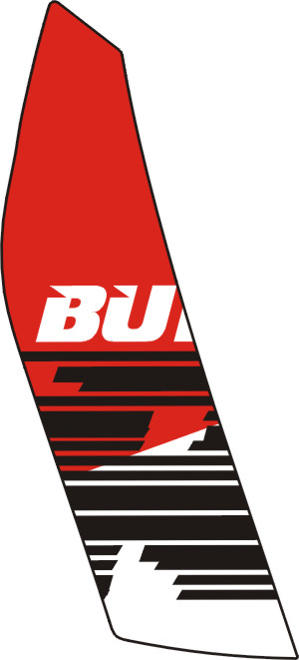 | 415008AR  415008PS | Emblem, FENDER, INNER, LH.
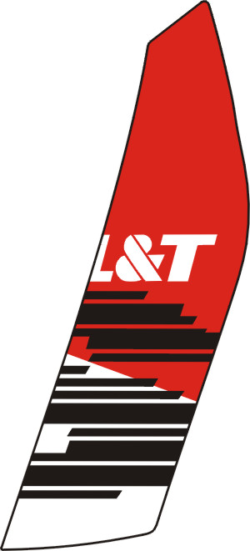 | 415009AR  415009PS | Emblem, FENDER, INNER, RH.
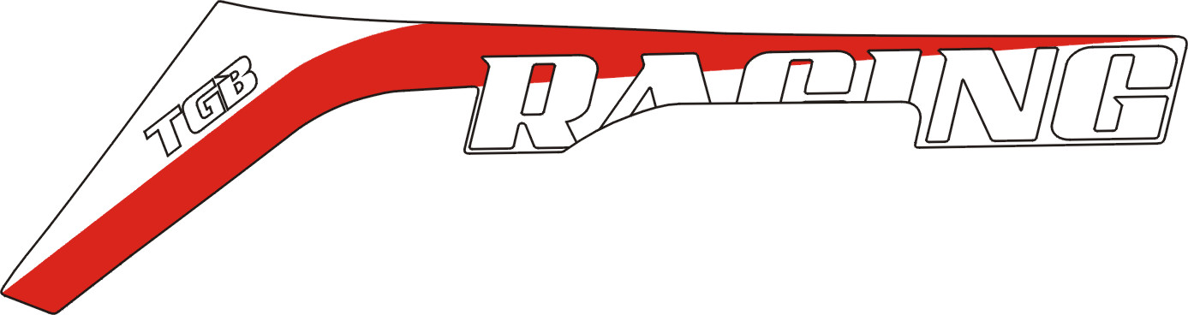 | 415010AR  415010PK | Emblem, Cover, Lower, LH.
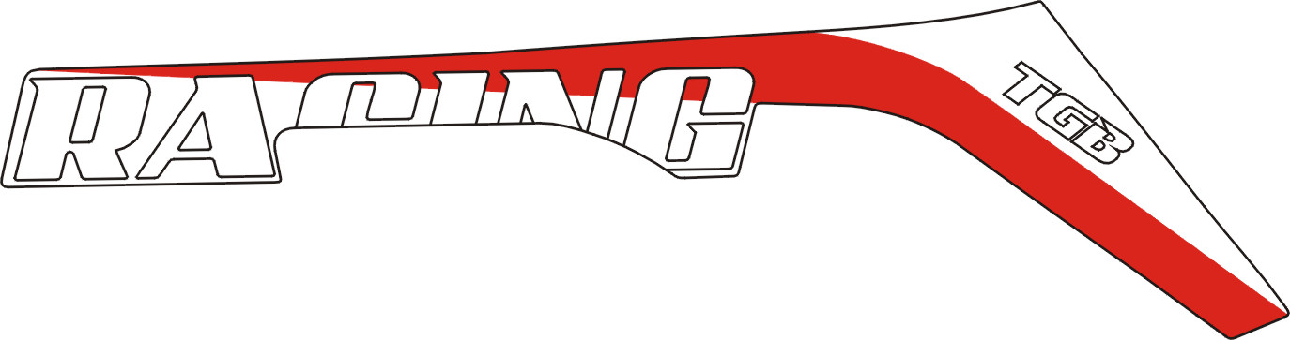 | 415011AR  415011PK | Emblem, Cover, Lower, RH.
 | 415012AR  415012PK | Emblem, Cover, Side Rear, LH.
 | 415013AR  415013PK | Emblem, Cover, Side Rear, RH.

II
BM8-B TABLE OF LABEL 2013
Label | Drawing | Description
 | 459987PS | Emblem, Cover, Seat, Front.
 | 415014AR  415014PS | Emblem, Cover, Seat, Front.
 | 415014PK | Emblem, HANDLE.
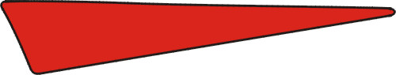 | 415015AR  415015PS | Emblem, Cover, Side Front., LH.
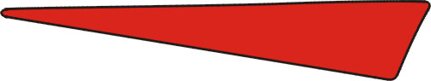 | 415016AR  415016PS | Emblem, Cover, Side Front., RH.
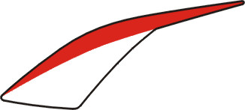 | 415017AR  415017PK | Emblem, Cover, Handle Bar, Front., LH.
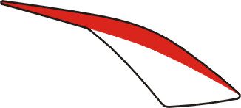 | 415018AR  415018PK | Emblem, Cover, Handle Bar, Front., RH.
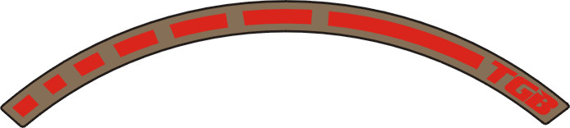 | 415019AR  415019LY | Emblem, Rim Comp., LH.
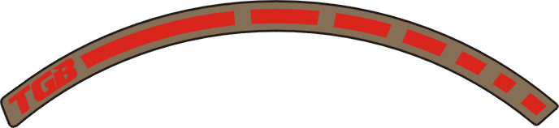 | 415020AR  415020LY | Emblem, Rim Comp., RH.
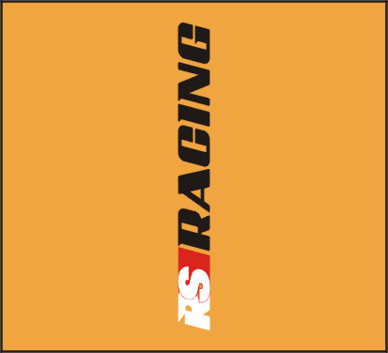 | 415021 | Emblem, Front Fork
 | 459934 | “TGB” Emblem

III
BM8-B TABLE OF LABEL 2010
Label | Drawing | Description
 | 459854SRB  459854SS  459854PYA 459854CG | Emblem, Cover, Side Rear, LH.
 | 459855SRB  459855SS  459855PY A 459855CG | Emblem, Cover, Side Rear, RH.
 | 459798SH 459798SE | “TGB”Emblem
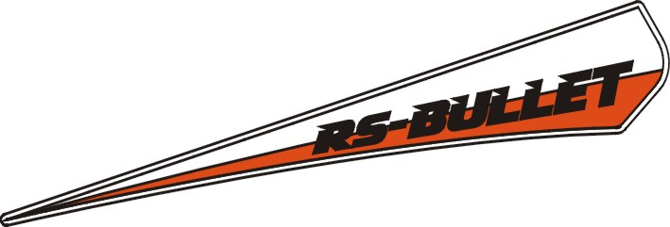 | 459858SRB 459858SS 459858PYA 459858CG | Emblem, Leg Shield, Front
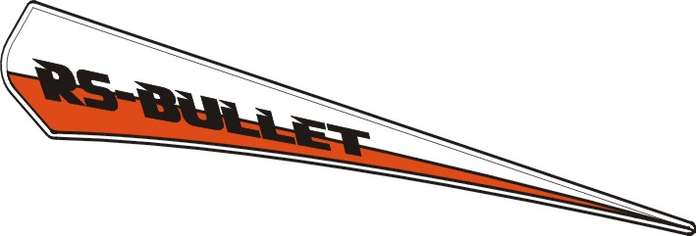 | 459859SRB 459859SS 459859PYA 459859CG | Emblem, Leg Shield, Front
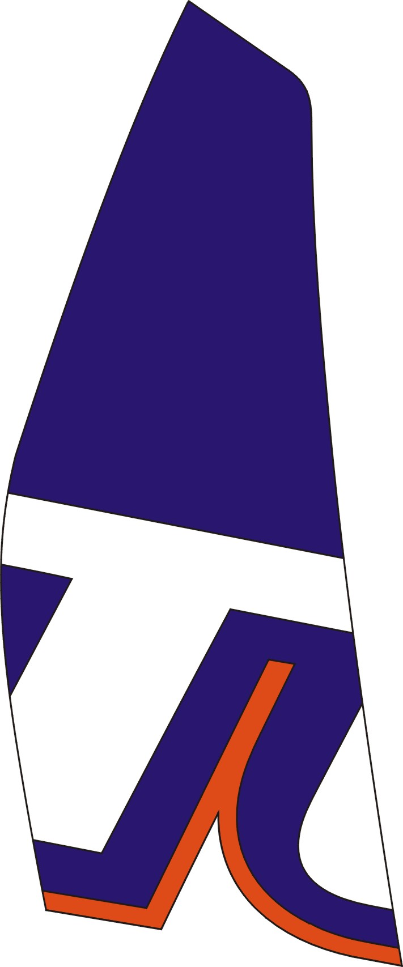 | 459852CB B 459852FE 459852CLA 459852SH | Emblem, FENDER, INNER
 | 459853CBB 459853FE 459853CLA 459853SH | Emblem, FENDER, INNER

I
BM8-B TABLE OF LABEL 2010
Label | Drawing | Description
 | 459848CBB 459848FE 459848CLA 459848SH | Emblem, Leg shield, Side, LH.
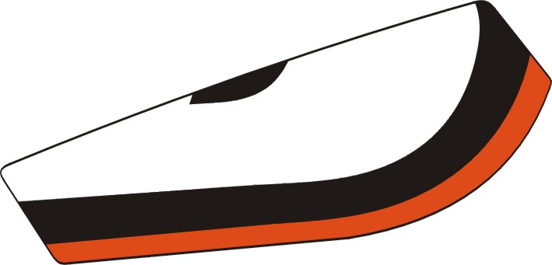 | 459849SRB 459849SS 459849PYA 459849CG | Emblem, Leg shield, Side, LH.
 | 459850CBB 459850FE 459850CLA 459850SH | Emblem, Leg shield, Side, RH.
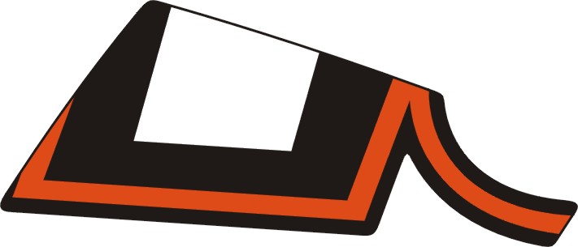 | 459851SRB 459851SS 459851PYA 459851CG | Emblem, Leg shield, Side, RH.
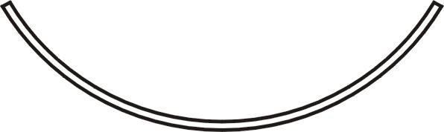 | 459862 | Emblem, Rim Comp.
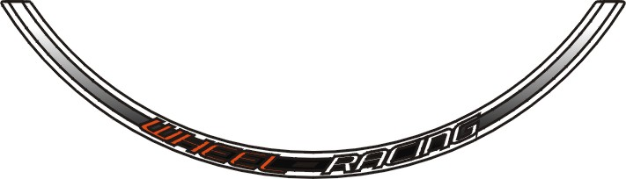 | 459856SRB 459856SS 459856PYA 459856CG | Emblem, Rim Comp.
 | 459857 | Emblem, Front Fork
 | 459720 | Emblem, Cover, Seat, Front

II

